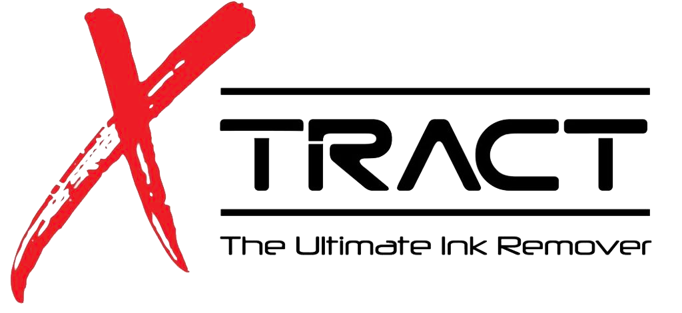

Client Profile & Treatment Plan

Name: _______________________________________________ Birth Date: ___________________________________
MM/DD/YY

Address: __________________________________________________________________________________________
Street City Prov. Postal Code

Phone: ____________________________________________________________________________________________
Home Work Cell

E-Mail: ___________________________________________________________________________________________

How did you hear about Xtract?

__________________________________________________________________________________________________

Occupation: ________________________________ Physician: ______________________________________

Check any boxes that apply currently, or have applied in the past:

- Accutane within past 2 years
- Alcohol: ______ per day
- Allergies to latex
- Anesthetic problems with dental work
- Any medical implants (within the past 2 years)
- Any type of heart disease/stroke
- Autoimmune disorder
- Bleed/bruise easily
- Communicable disease
- Diabetes
- Drugs, prescription/recreational
- Eczema
- Fish oils or Omega supplements
- Fainting/dizziness
- Hemophilia
- Nauseous at the sight of blood
- Hepatitis/Jaundice
- High/low blood pressure
- HIV/AIDS positive test
- Hyper-pigment (darkened scars)
- Hypo-pigment (lightened scars)
- Keloid or hypertrophy scars
- Pacemaker
- Physician's care for any medical condition
- Pregnant or nursing
- Psoriasis
- Radiation or chemotherapy treatment
- Rosacea
- Seizures
- Smoking: ______ per day, _______ years

Describe any checked boxes:
__________________________________________________________________________________
__________________________________________________________________________________

Description of tattoo, including size, location and color:
____________________________________________________________________________________________________________________________________________________________________________________

List any adverse reactions experienced after the application of the tattoo including infections, swelling and/or bleeding ?________________________________________________________________________
Why are you interested in receiving a removal today? What is your desired results of this procedure?
________________________________________________________________________
________________________________________________________________________

Have you had any previous removal procedures?
________________________________________________________________________

It is estimated that the attempt to remove the tattoo will take approximately ______ treatments, scheduled at least 6 to 8 weeks apart. Client agrees not to pursue alternative removal treatments during this time-period.

Client will follow the provided ‘Aftercare Instructions’ and will contact the technician listed below with any questions or concerns following each treatment.

Client affirms they have fully disclosed the entire relevant history of the tattoo. By affixing the signatures below, both client and technician have discussed the ‘Client Profile & Treatment Plan’, and both agree that the information is fully understood.

Client Signature: ____________________________________Date: _______________________________

Technician Signature: ________________________________Date: _______________________________

Informed Consent
Lightening and/or Extraction of Pre-Existing Tattoo Ink
The nature, method and all risks of the proposed tattoo ink lightening or removal procedure has been explained to me. I was given full opportunity to ask any questions. _______ (Client Initials)
I understand that there may be a certain amount of discomfort or pain associated during and after the procedure. Other rarely occurring adverse side effects may include but are not limited to lightening or darkening, scarring, or infection of the skin. _______ (Client Initials)
I clearly understand ALL THE RISKS involved and the likelihood of any adverse reactions to the procedure. Xtract, will work with you to help achieve the best results possible._______ (Client Initials)
I understand there are other medical options, including Laser, available for removal of ink or pigment. I have decided to decline those methods._______ (Client Initials)
I understand that several treatments may be needed in order to achieve my desired results; however, I understand that there is no guarantee or assurance as to the ultimate outcome or result of this procedure. I understand that once the procedure is completed, Xtract, has a NO REFUND POLICY. _______ (Client Initials)
I will not hold my technician, Xtract, or any owners, employees or independent contractors of Xtract, liable for any damages that may occur to my person._______ (Client Initials)
I understand that the complete removal of tattoos is difficult. As a result, I will not hold my technician or this establishment responsible for any resultant failure to lighten or remove completely the unwanted ink._______ (Client Initials)
I agree to follow all instructions concerning the care of my tattoo removal procedure area, while healing. I agree that any complications resulting from my negligence, is totally my responsibility._______ (Client Initials)
I understand that I will be given written instructions for post procedure care and follow-up, and also understand that I will make a 48 hour wound check appointment._______ (Client Initials)
I agree to submit to before and after photographs and I give my permission to use such photographs for publication and/or for teaching purposes only upon signing an additional release form_______ (Client Initials)
I understand all information listed above, have had all my questions answered and agree to all conditions and provisions of this document as evidenced by my signature below. I accept the risks for having this procedure done and I voluntarily request that the tattoo lightening and removal procedure(s) are to be performed on me._______ (Client Initials)
I understand that I am a model and students will be working on my tattoo removal with the supervision of a trainer. I understand the discount given to me will continue for any further treatments if needed. I also understand that I will keep my technician updated during my healing process, which will include pictures. ________ (Client Initial’s)

Patient/Client: _______________________________ Date: ____________________

